Press Release
Milan, Dicember 6th, 2016
Promotedesign.it confirms its attendance at Milan Design Week 2017
150 international designers
- Special Guest Simone Micheli -
DIN-DESIGN IN 2017
#din2017
Now became a must of the Milan Design Week, Promotedesign.it organizes the huge expositive event Din - Design In be in the strategic location of Via Massimiano 6/ via Sbodio 9, in the Lambrate District.
As for the past editions there will be the chance to admire the ideas of more than 150 designers from all over the world with more than 600 products exhibited, from hi-tech items to creations with a high artistic and innovative features.
The Milan Design Week will start on Tuesday 4th April 2017 and it will finish on Sunday the 9th April 2017. Din-Design In will become once again the temple of the international self-produced design. Thanks the organization of the several and different initiatives, such as free workshops, editorial launches, happy hours and meetings with influential multinational corporations of the sector, the event will be one of the most important and popular ones during the Milan Design Week 2017.
During Fuorisalone 2017 Simone Micheli Architect will give birth to "“Heart’s serviced apartments for Art – Business – Mountain - Sea”"; a new concept linked with the world of hospitality and aimed by the purpose of showing the innovative approaches of this field.
In the district of Lambrate, will take shape an exhibition that - with a curious and attentive eye, aimed to imagine future scenarios which will characterize the world of hospitality - will offer a careful and deep overview of the changes that are taking place during recent years. The 4 serviced apartments are suitable models to be positioned in 4 different and suggestive locations - seaside, mountains, countryside and cities – The apartments will be created on the basis of the real needs that the guest wants to be satisfied when he decides to try a new way of staying, aimed at socializing, sharing the experience and getting in touch with the life that each place offers to its visitors. The event will also include the creation of a lounge area. It will be an intriguing hospitable place that businesses and visitors can use to cross their paths and to exchange information.
Promotedesign.it has as primary goal putting in contact and attracting the interest of the design-producers and buyers and making them aware of the increasing creativity offer.
For this purpose, every year, various collateral events are created, like the Temporary Shop area in which Treneed.com and Artistarjewels.com are reconfirmed after last year’s success. Treneed.com and Artistarjewels.com are both e-commerce channels oriented to the online sale of design items and contemporary jewellery. Din – Design In if for them the opportunity of emerging from the virtual world and selling directly through the Temporary Shop available only during the Din event.
Projects developed by Promotedesign.it are:
Design For, a book/catalogue with the best design-concepts carefully chosen by Promotedesign.it; a very useful tool to all the manufacturing firms that have the possibility of selecting the best ideas from international designers.
Din-Design In, an expositive event created to give the chance to self-produced-designers to show their creations to an international audience and to allow a greater distribution of their concept.
Treneed.com, an e-commerce channel for the all the self-producer and the design enthusiast that through the website have the possibility of selling and buying.
More info
Promotedesign.it
We are a collective of designers and architects whose goal is to promote creativity and design. Through the web portal and the offer of numerous service we put into contact all the actors in the sector. We collaborate with several bodies, as manufacturing firms, universities, specialized schools and publishing houses in order to favor the realization of different planning projects that help the increase of the debate.
The web portal also include several institutions related to the design universe, like prototype laboratories, photographers, press offices and more, to offer the registered users a network in constant change. The portal wants to be not only a useful working tool but also an opportunity to develop collaborations.
All the subscribers can create a professional profile from which manage independently all the personal information. In the profile the user will upload pictures of products, concepts, developing projects, descriptions of those projects and also a biography/cv. The system works for designers, firms and all those who wants a relevant service.
In addition, users will be offered the possibility of using promotional, learning and refreshing training services. Contests, free workshops, events, commercial partnerships are constantly offered.
More info about Promotedesign.it
Information and Contacts for the Visitors
DIN – Design In
Dates: from 4th to 9th April 2017
Place: Via Massimiano 6 / via Sbodio 9 (Lambrate District)
Opening hours: everyday from 10 am to 8 pm
Extraordinary opening evening: 6th April from 10 am to 00:00
Note: 9th of April opening hours from 10:00 am to 6:00 pm
Free entry
INFORMATION FOR THE PRESS
Press office Promotedesign.it
Phone: 0039 02.36.58.02.08
Mobile: 0039 320 016 7255
Email: press@promotedesign.it
The Press Kit includes press relieses, company profiles, high and low resolutions images and is available to the following link: press kit
Website: promotedesign.it
Facebook: facebook.com/Promotedesign
Twitter: @Promote_design
YouTube: youtube.com/user/PromoteDesign
Instagram: instagram.com/promotedesign.it

#din2017
In Media Partnership with:
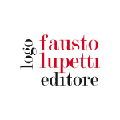 | 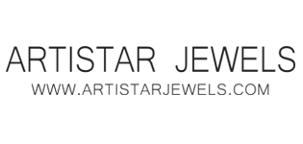 | 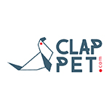
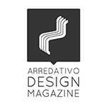 | 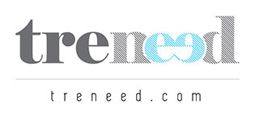 | 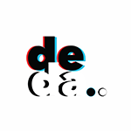
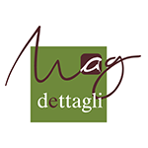 | 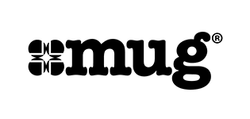
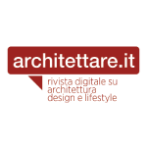 | 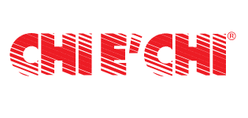
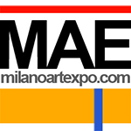 | 